INTERIM PROGRESS REPORT

Project Title
Design and Evaluation of a Git-Based Health Scorecard for Software Project Quality Analysis
Module Title
Advanced Computer Science Masters Project
Student Number and Name
Student Number: 24069748
Name: Visalraj Neelanchery
Supervisor Name
Maryjane Betrand

1. Background Research and Literature Research

1.1 Introduction, Goals and Research Problem
GitHub and other distributed, open-source collaboration platforms are becoming more and more important in modern software development. Although metrics at the repository level, such stars, forks, and commit frequency, are frequently used to determine the popularity of a project, they may not accurately represent more profound facets of software quality and maintainability.
Designing and implementing a program that automatically assesses Git-based repositories and creates a structured health scorecard using quantifiable software engineering indicators is the aim of this project.
The main issue with the research is:
Is it possible for observable indicators at the repository level to function as a trustworthy proxy for long-term maintainability and software project health?
This problem tackles measuring issues in software engineering from a theoretical and practical standpoint.

1.2 Research Questions
The research is guided by the following questions:
- How do commonly used indicators such as GitHub stars, forks, and contributor engagement relate to health scores derived from repository metrics?
- What limitations arise when assessing project health solely through Git-based metadata?
- Which measurable repository-level metrics most effectively represent project health?
- To what extent can automated health scoring align with manual qualitative assessments?

1.3 Objectives
The following are the project's goals:
- To define software project health from academic and industry perspectives.
- To identify measurable GitHub repository metrics.
- To design and implement a modular tool using the GitHub REST API.
- To develop a quantitative scoring framework.
- To empirically evaluate 15–20 open-source repositories.
- To analyse correlation between popularity metrics and computed health scores.
- To perform qualitative manual validation.
- To critically evaluate the methodology.
These objectives are measurable and aligned directly with the research questions.

1.4 Background Research and Critical Literature Analysis

1.4.1 Mining Software Repositories as a Foundational Discipline
A major change in empirical software engineering was brought about by Hassan et al. (2005), who formally established Mining Software Repositories (MSR) as a disciplined research area. Their research established repository metadata, such as defect databases, issue trackers, and commit histories, as a valuable empirical resource for comprehending software evolution.
Their large-scale empirical investigations demonstrated that:
- Repository metadata provides longitudinal insight into development trends.
- Historical commit patterns can support defect prediction.
- Maintenance planning can be informed by empirical evidence.
Importantly, this work established MSR as a field based on software analysis driven by data. MSR does not synthesise these signs into a single evaluative construct, even if it makes it possible to extract repository-level information in an organised manner. One significant weakness is the lack of a quantitative, cross-project health score.
The complete evaluative framework that this project aims to create is not provided by MSR, but it does supply the data foundation.

1.4.2 Visualising Software Evolution and Structural Instability
Hassan, Wu and Holt (2004) introduced spectrograph-based visualisation techniques to interpret software evolution patterns. By analysing version control histories, they identified:
- Burst patterns correlating with instability phases.
- Persistent maintenance hotspots.
- Hidden structural risks embedded in change trajectories.
Their research showed that structural and temporal risk signals are encoded in repository history. The suggested method was still mostly interpretive and visual, though. It lacked quantitative transformation, but it worked well for expert-driven maintenance decision-making.
Visual cues were not used to generate any numerical scoring models. Furthermore, automated large-scale cross-repository comparison was not supported by the framework.
This draws attention to a methodological flaw:
While visual analytics can identify trends, they are unable to convert those trends into quantifiable, comparative health measurements.
By converting observable patterns into weighted, computational indicators under a single scoring framework, the current study expands on this idea.

1.4.3 Community Interaction and Sustainability
Gonzalez-Barahona (2013) shifted the focus from purely technical metrics to socio-technical dynamics within open-source ecosystems. By examining contribution records and corporate participation patterns, the study found:
- Contributor diversity enhances resilience.
- Corporate involvement influences sustainability trajectories.
- Community engagement directly affects long-term project continuity.
This research introduces an important theoretical dimension: software health is not purely technical but socio-technical. Sustainability emerges from both structural code quality and collaborative dynamics.
However, limitations remain:
- Social indicators were not integrated with technical repository metrics.
- No composite sustainability index was proposed.
- Automated Git-based health scoring was not operationalised.
Thus, while socio-technical awareness was introduced conceptually, it was not computationally formalised.
The current project directly builds on this insight by incorporating contributor participation into a measurable scoring structure alongside technical indicators.

1.4.4 Code Review Practices and Quality Assurance
Bird (2013) examined modern code review workflows using pull request and review data. Findings indicated:
- Structured review processes reduce defect introduction.
- Reviewer expertise improves stability.
- Communication quality affects efficiency.
This study strengthens the argument that review metrics can serve as proxies for code quality and maintenance discipline. Yet, its scope was limited to review workflows.
The research did not:
- Integrate review activity with documentation or commit patterns.
- Develop a unified project-level health measure.
- Support cross-project comparative evaluation.
Thus, review quality was examined in isolation rather than as part of a holistic repository health model.

1.5 Synthesis of Research Gaps
Across all four streams of research, a pattern emerges:
Research Stream | Strength | Limitation
MSR (Hassan et al.) | Data-driven empirical analysis | No unified health index
Evolution Visualisation | Structural pattern detection | No quantifiable scoring
Community Sustainability | Socio-technical insight | No computational integration
Code Review Studies | Quality improvement evidence | No holistic project scoring
Collectively, the literature demonstrates that:
- Repository metadata is valuable.
- Socio-technical signals matter.
- Historical trends encode maintenance risk.
- Review processes influence quality.

However, none of the examined studies:
- Integrate technical, social, and process indicators into a unified quantitative score.
- Provide automated cross-project comparison capability.
- Critically validate automated health scoring against manual assessment.
- Investigate correlation between popularity indicators (stars, forks) and deeper structural health.
This reveals a clear and academically grounded research gap:
There is currently no empirically validated, automated, multi-metric scoring framework that integrates repository metadata into a unified, cross-project health assessment model.

1.6 Theoretical Positioning of the Current Study
This project positions itself at the intersection of:
- Mining Software Repositories (data extraction)
- Socio-technical systems theory
- Quantitative software quality modelling
- Empirical validation through mixed-methods evaluation
Rather than proposing a purely technical tool, the study aims to:
- Operationalise theoretical constructs of maintainability and sustainability.
- Translate qualitative insights into computational metrics.
- Empirically test whether automated scores align with human judgement.
- Examine whether popularity metrics are statistically correlated with structural health.

This approach advances existing research by:
- Converting fragmented repository indicators into a unified scoring artefact.
- Introducing empirical cross-repository comparison.
- Combining automation with manual qualitative validation.
- Critically analysing methodological limitations.

1.7 Contribution to Academic Knowledge
The contribution of this project lies in:
- Designing a modular, automated Git-based health scoring system.
- Providing empirical evidence on the reliability of repository-derived surrogate measures.
- Bridging theoretical MSR foundations with applied scoring implementation.
- Introducing validation mechanisms that address known limitations of automated metrics.
By grounding the scoring framework in established research while addressing documented gaps, the project contributes both practically (tool development) and theoretically (evaluation of surrogate health indicators).

2. Summary of Progress to Date
This section outlines progress achieved as of March.

2.1 Literature Review Completion
A focused literature review has been conducted covering:
- Software maintainability models
- Repository mining research
- Open-source sustainability indicators
- Empirical evaluation methodologies
Key theoretical foundations have been identified, and research questions refined accordingly.

2.2 Scoring Framework Drafted
A conceptual scoring model has been drafted.
The framework proposes weighted categories including:
- Commit activity
- Issue and pull request dynamics
- Contributor participation
- Documentation presence
- Testing indicators
Weight distribution has been conceptually defined but not yet implemented programmatically. Refinement will occur after empirical testing.

2.3 System Architecture Design
The system architecture has been defined as:
- Frontend: Built using Next.js
- Backend: API routes inside Next.js
- Data Source: GitHub REST API
- Database: None currently implemented
The system is modular, allowing metric extraction logic to remain separate from presentation logic.

2.4 Development Progress
The following development tasks have been completed:
- Project codebase initialized.
- Frontpage UI designed using Next.js.
- Main component structure created (UI level).
- Routing framework prepared for future API integration.
The current frontpage is static and not yet integrated with the GitHub API. Backend API routes are structured but metric retrieval logic is still pending.

2.5 Technical Challenges
The primary challenge identified is GitHub API complexity, including:
- Understanding endpoint structure.
- Managing rate limits.
- Handling pagination.
- Designing efficient metric extraction logic.
To address this:
- Official GitHub documentation is being studied.
- Endpoint mapping strategy is being drafted.
- Incremental integration testing is planned.

2.6 Work Planned for End of March
- Implement API calls.
- Test successful metric extraction.
- Select 15–20 repositories.
- Begin manual qualitative review of 5–7 repositories.
- Implement preliminary scoring logic.

3. Ethical, Legal, Professional and Social Considerations

3.1 Ethics Approval
Ethics approval is not required as the project uses only publicly available GitHub repository data. No personal or sensitive data is collected beyond publicly visible metadata.

3.2 Legal Considerations
The project complies with:
- GitHub API terms of service.
- Public data usage policies.
- GDPR principles (no personal identifiable information stored).
If expanded in the future to include contributor profiling, ethical approval may become necessary.

3.3 Professional Standards
The project follows professional software engineering practices:
- Modular architecture.
- Clear separation of concerns.
- Planned validation procedures.
- Transparent scoring methodology.

3.4 Social Impact
Automated scoring systems may:
- Influence perceptions of project quality.
- Potentially disadvantage smaller repositories.
- Oversimplify complex socio-technical systems.
To mitigate bias:
- Results will be critically interpreted.
- Manual qualitative validation will complement automation.

4. Project Plan

4.1 Management Approach
A hybrid iterative approach is adopted:
- Structured milestone planning.
- Incremental technical development.
- Continuous supervisor feedback.

4.2 Remaining Tasks
March:
- GitHub API integration.
- Repository selection.
- Begin manual review.

Early April:
- Implement scoring computation.
- Perform quantitative analysis.
- Correlation testing.
Mid April:
- Interpret results.
- Write an evaluation chapter.
- Discuss limitations.
Late April (Before 27 April):
- Final report writing.
- Refinement and proofreading.
- Demonstration preparation.

4.3 Risk Management
Primary risk: API complexity and time constraints.
Mitigation:
- Incremental endpoint testing.
- Limiting scope if required.
- Prioritising core metric implementation first.

5. Level of the Project
This project qualifies as MSc level due to:
- Integration of theory and practical implementation.
- Empirical statistical evaluation.
- Mixed-methods validation.
- Critical analysis of methodology limitations.
- Development of a novel scoring artefact.
The work involves:
- Designing a modular system architecture.
- Quantitative experimentation.
- Manual validation.
- Correlation testing.
- Critical reflection on surrogate measurement validity.
It goes beyond simple software development by contributing to research on software health measurement.

6. References (Harvard Style)
Hassan, A.E., 2008. The road ahead for mining software repositories. In: Proceedings of the 2007 Future of Software Engineering (FOSE ’07). Minneapolis, MN, USA, 23–25 May 2007. IEEE Computer Society Press, pp.
Holt, R.C., 2001. Software architecture as a shared mental model. In: Proceedings of the IBM Centre for Advanced Studies Conference (CASCON 2001). Toronto, Canada. IBM Press, pp.
Bird, C., Rigby, P.C., Barr, E.T., Hamilton, D.J., German, D.M. and Devanbu, P., 2009. The promises and perils of mining Git. In: Proceedings of the 6th IEEE International Working Conference on Mining Software Repositories (MSR 2009). Vancouver, BC, Canada, 16–17 May 2009. IEEE, pp.
González-Barahona, J.M., 2010. Understanding how companies interact with free software communities. IEEE Software, 27(6), pp
GitHub. (2023). GitHub REST API Documentation. Available at: https://docs.github.com/en/rest (Accessed: [29/01/2026]). Official documentation describing the APIs used to retrieve repository metadata and activity metrics.

Appendices

Appendix 1: Browser View of Working Application


Appendix 2: Source Code Snippets
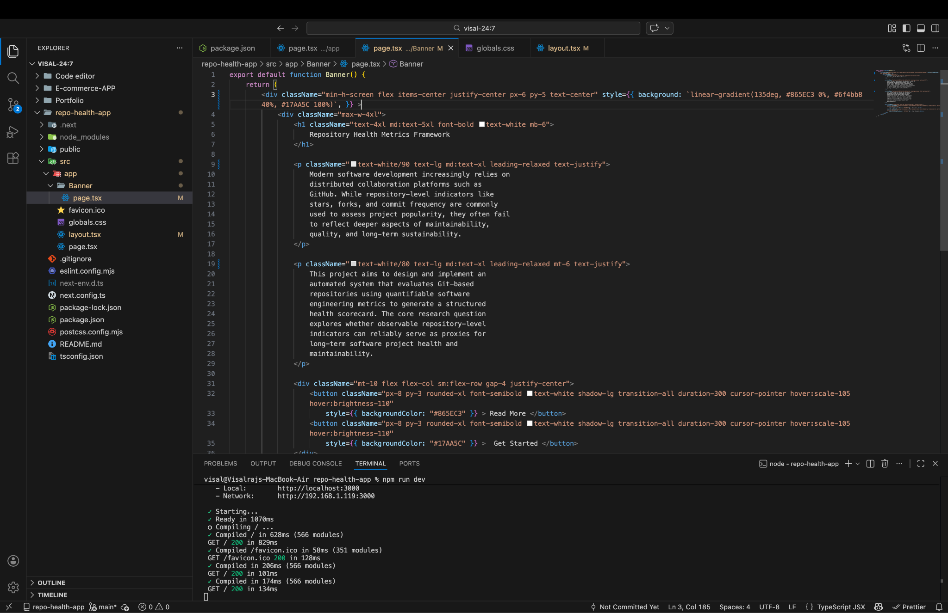

Appendix 3: Version Control Branch and Commit History Evidence
